**DAILY ONLINE ACTIVITIES SUMMARY**

|  |  |  |  |  |  |
| --- | --- | --- | --- | --- | --- |
| **Date:** | | **15/06/2020** | | **Name:** | **KHATHEEJA SAFREENA.** |
| **Sem & Sec** | | **4th & ‘A’** | | **USN:** | **4AL18CS037.** |
| **Online Test Summary** | | | | | |
| **Subject** | **-------------** | | | | |
| **Max. Marks** | **--------------** | | **Score** | | **-------------** |
| **Certification Course Summary** | | | | | |
| **Course** | | **Introduction to Cyber Security.** | | | |
| **Certificate Provider** | | **Great learning.** | **Duration** | | **6 hours.** |
| **Coding Challenges** | | | | | |
| **Problem Statement:1)**  Write a Java Program to find if string is K-Palindrome or not. | | | | | |
| **Status: complied** | | | | | |
| **Uploaded the report in Github** | | | **yes** | | |
| **If yes Repository name** | | | **[http://shafreenasharief / lockdown-coding](http://shafreenasharief / lockdown-coding" \o "http://shafreenasharief / lockdown-coding)**  **[http://shafreenasharief / locked-down--certification-course](http://shafreenasharief / locked-down--certification-course" \o "http://shafreenasharief / locked-down--certification-course)**  **[http://shafreenasharief / Daily\_Report](http://shafreenasharief / Daily_Report" \o "http://shafreenasharief / Daily_Report)** | | |
| **Uploaded the report in slack** | | | **yes** | | |

Certification Course Details: (Attach the snapshot and briefly write the report for the same)

Coding Challenges Details: (Attach the snapshot and briefly write the report for the same)

**CERTIFICATION COURSE SUMMARY**:

Today I started new course INTRODUCTION TO CYBER SECURITY through GREAT LEARNING the course is secluded for 6hrs. After the completion of course, certificate will be provided. I completed all the module .I attempted quiz ,which gave me a clear veiw about the topics that were thought and discussed.It consists of 7 modules which also include assessments.

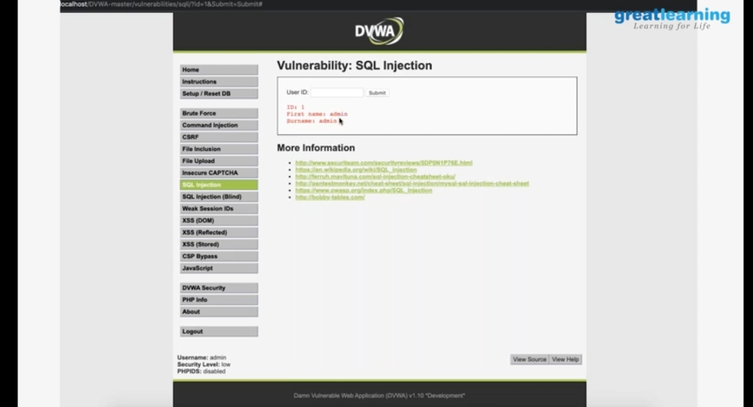

I successfully completed certification course on **INTRODUCTION TO CYBER SECURITY**.It consists of 10 modules including assessments.

**The concept covered in the course are as follows:**

* Blockchain in Cyber security.
* Career and industry landscape.
* Governance and Risk.
* Introduction to Cryptography.
* Secure and Design System.
* Threats and Vulnerability.
* What is cyber security.

**There is the snapshot of e-certificate provide after the completion of course.**

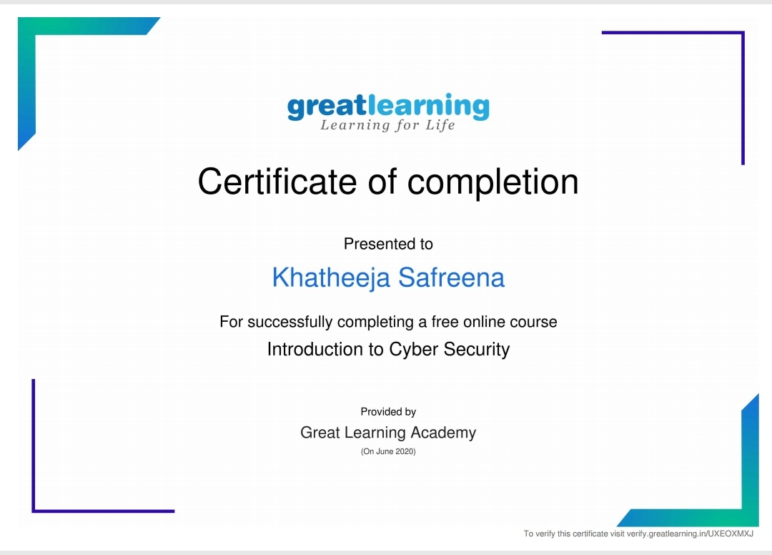

**CODING CHALLENGES**:

Today I solved coding challenge,

**PROBLEM STATEMENT**: Write a Java Program to find if string is K-Palindrome or not

A string is k palindrome if it can be transformed into a palindrome on removing at most k characters from it. Your task is to complete the function is\_k\_palin which takes two arguments a string str and a number N. Your function should return true if the string is k palindrome else it should return false.

Input:

The first line of input is an integer T denoting the number of test cases. Then T test cases follow. Each test case contains a string str and an integer N separated by space.

Output:

The output will be 1 if the string is k palindrome else 0.

Example

Input: String - abcdecba, k = 1

Output: Yes

String can become palindrome by removing 1 character i.e. either d or e)

Input: String - abcdeca, K = 2

Output: Yes

Can become palindrome by removing

2 characters b and e.

Input: String - acdcb, K = 1

Output: No

String cannot become palindrome by

removing only one character.

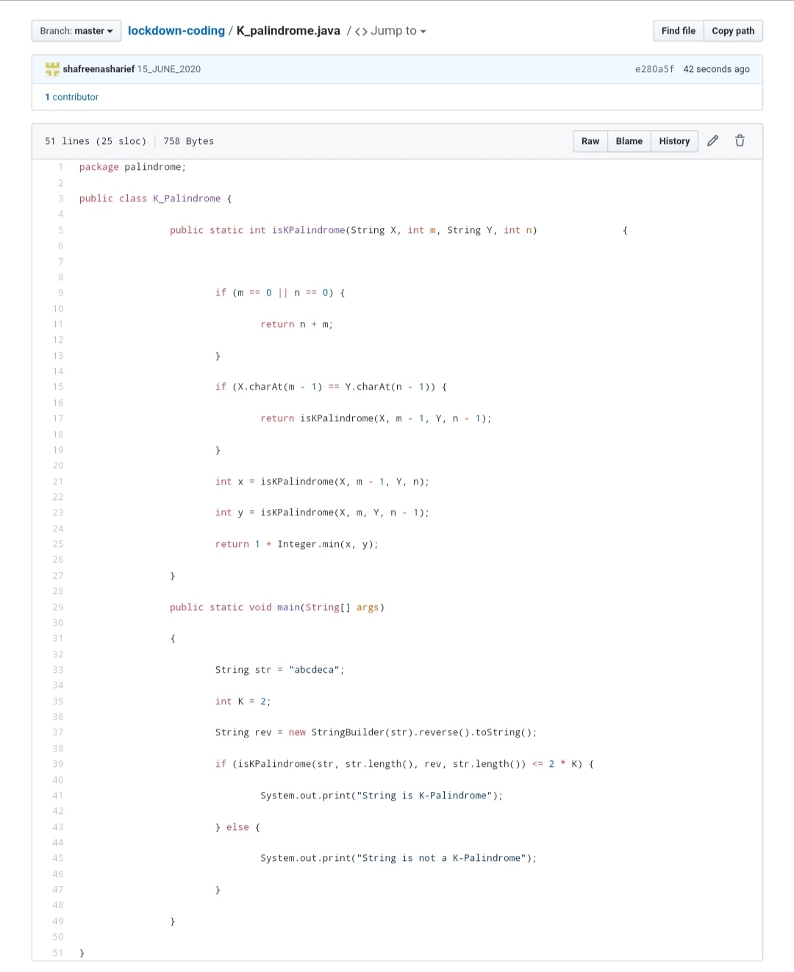

**SOLUTION** : I have uploaded the solution of the above 3 coding problems in my GitHub repository.

[http://shafreenasharief / lockdown-coding](http://shafreenasharief / lockdown-coding" \o "http://shafreenasharief / lockdown-coding)

[http://shafreenasharief / locked-down--certification-course](http://shafreenasharief / locked-down--certification-course" \o "http://shafreenasharief / locked-down--certification-course)

[http://shafreenasharief / Daily\_Report](http://shafreenasharief / Daily_Report" \o "http://shafreenasharief / Daily_Report)